- What is the point of normalization?

Normalization helps to reduce data redundancy, improving both performance and storage efficiency, while streamlining data processing methods and to reduce mistakes from updating data due to needing dependencies to be updated manually.

- Is a table with a single attribute primary key automatically in second normal form? Why?

Yes. A table with a single attribute primary key automatically is in 2NF as if the primary key only has a single attribute, it means that even in 1NF, all the other attributes can ONLY depend on that one primary key anyways, eliminating any partial dependencies already.

- Use the dependency diagram to answer the questions.
  - Identify and discuss each of the indicated dependencies.

C1 and C2 form a composite primary key (CPK).
C3 depends on the CPK.
C4 through C7 is partially dependent on C2, a part of the CPK.
C8 is partially dependent on C1, a park of the CPK.
C6 is transitively dependent on C7.

  - What changes do you need to make to go to 2NF? Make the dependency diagram(s).

Move C8 to a new table where C1 is the PK.
Move C4 through C7 to a new table where C2 is the PK.
C3 remains with C1 + C2 as the PK.

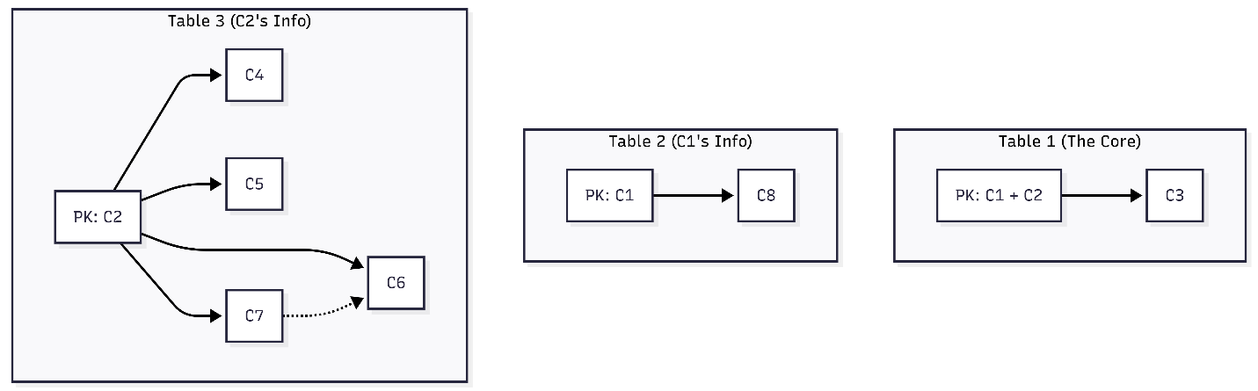

  - What changes do you need to make to go to 3NF? Make the dependency diagram(s).

Remove transitive dependency between C6 and C7 by creating a new table where C7 is a PK and FK which points to C6.

